H.U. MECHANICAL ENGINEERING

GENERAL CHEMISTRY LAB REPORT

THE COMBINING RATIO BY WEİGHT OF

COPPER AND SULPHUR

GÖKAY KART

KIM-121-6

ZÜHRA ÇINAR

In this experiment, we will react with copper and sulfur, paying attention to the law of conservation of mass, the law of definite proportions and the law of multiple proportions. Our goal is to find the simple formula of the copper sulfide compound formed.

**Law of Conservation of Mass**

In a closed system, the mass of any chemical reaction and reactants must be equal to the mass of the products. The law of conservation of mass was first clearly defined by Lavoisier in 1789.For this reason, he is sometimes said to be the father of modern chemistry.

For example, 1 mole of C atoms is 12 grams, 1 mole of O2 molecules is 32 grams. Accordingly, 1 mol of CO2 atoms is 44 grams.

**C + O**2 **🡪 CO**2

**12 gram + 32 gram 🡪 44 gram**

Another example;

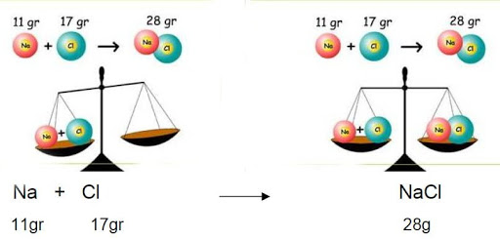

**Law of Definite Proportions**

There is a fixed ratio between the masses of the elements that make up the compound. This ratio is called the law of definite proportions. This law was found in 1799 by Joseph Proust. He has made the following definition for the law of definite proportions.

“When an element combines with another element to form a compound, the mass ratio of the elements in the compound is constant.”

For example, 18 grams of water has 16 grams of oxygen, while the remaining 2 grams is hydrogen. If 9 grams of water is taken, 8 grams of oxygen and 1 gram of hydrogen. This rate is absolutely fixed.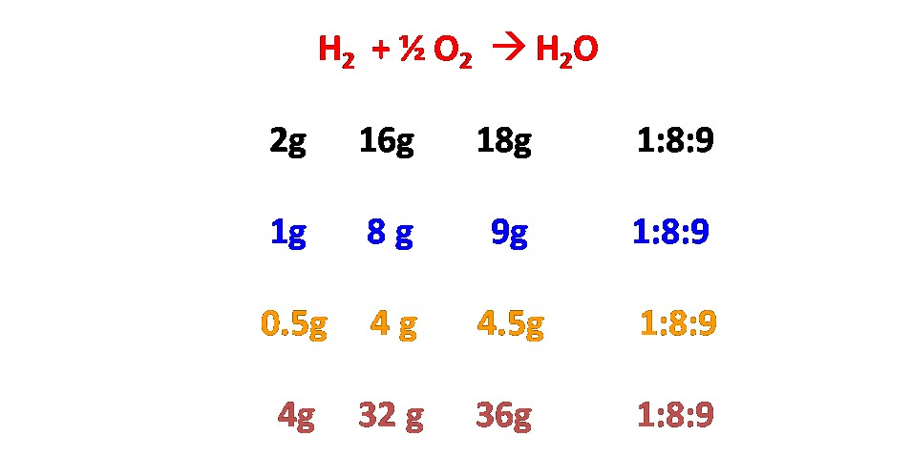

**Law of Multiple Proportions**

This law is realized between the elements that make up more than one compound between them. The amount of one of the elements in the compounds is kept constant and the ratio of the other is used. This law was discovered in 1804 by the English chemist John Dalton. It is expressed in ratios of small integers (ex: 4:3 or 3:2).

To comply with this law:

* Compounds should consist of two types of elements.
* The types of elements in the compounds must be the same.
* Simple formulas for compounds should not be the same.

For example:

* **CH**4 **: C**2**H**6 4:3
* **SO**2 **: SO**4 1:2
* **H**2**O : H**2**O**2 1:2
* **NH**3 **: N**2**H**4 3:2
* **KCIO : KCIO**4 does not obey the law
* **H**2**S : SO**2 does not obey the law
* **Mg0 : Mg0**2 1:2

For example, according to the carbon dioxide-carbon monoxide example, 44 grams of carbon dioxide has 12 grams of carbon and 32 grams of oxygen. There are 12 grams of carbon and 16 grams of oxygen in 28 grams of carbon monoxide. Since the amount of carbon in both compounds is the same, there are 32 grams of oxygen in one and 16 grams in the other. The ratio of the mass of oxygen in the first compound to the second compound is 16/32 => 1: 2.

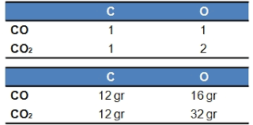

**Limiting Reactants;**

* The limiting reactant is the reactant that determines the amount of product in a reaction.
* The reaction will stop when all the limiting reactant is consumed.
* The limiting reactant helps calculate the theoretical yield of the reaction

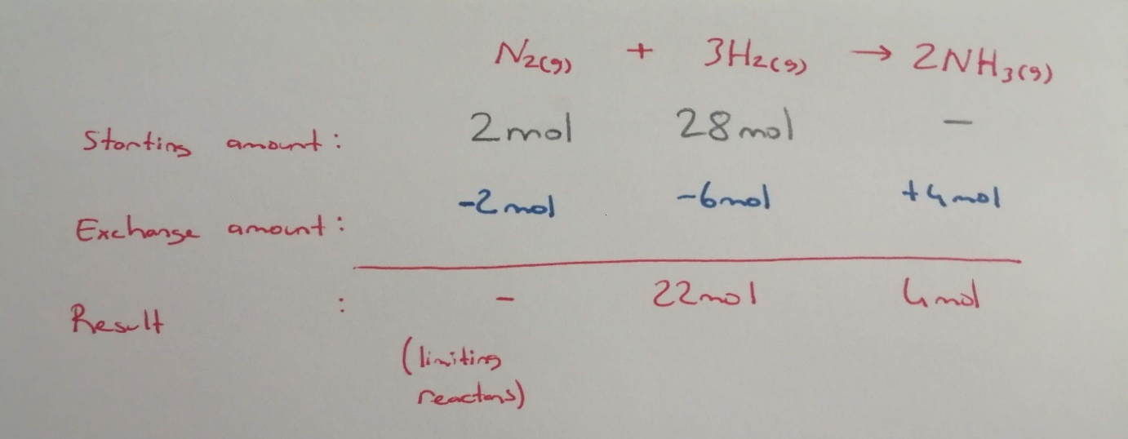

**Data of the experiment;**

* Mass of copper wire (m1) >>>0,47 g
* Mass of empty crucible (m2) >>>26,67 g
* Mass of crucible and copper sulfid (m3) >>>27,22 g
* Molar mass of sulfur >>>32 g
* Molar mass of copper >>>63,5 g

**Calculations of the experiment;**

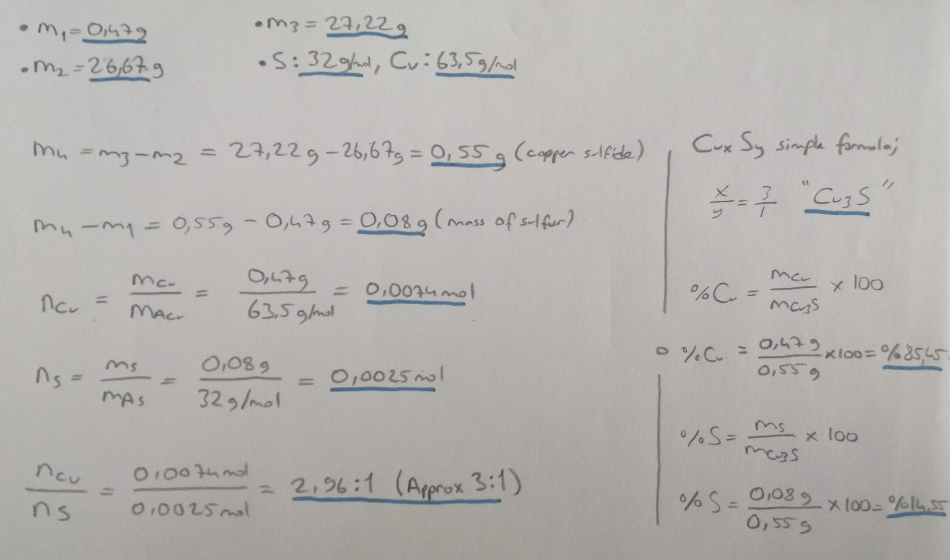

**Results of the experiment;**

Mass of copper sulfide: (m4) 0,55 g

Mass of sulfur combined with copper: 0,08g

Mass of crucible and copper sulfide: 27,22 g

Moles of copper atoms: 0,0074 mol

Moles of sulfur atoms: 0,0025mol

Copper moles / sulfur moles ratio: 2,96 : 1 (Approx 3 : 1)

The simple formula of the CuxSy formule: C**3**S

CuxSy composition: %Cu = %85,45 %S = %14,55

We heat the empty crucible at the beginning of the experiment so that no substance remains from the previous experiment. We put the copper measured on the precision scale into the crucible. We added enough sulfur to cover the copper completely. (The amount is insignificant) We closed the lid of the crucible and started the reaction.

The reason why the amount of excess sulfur is not important in the reaction is that the excess sulfur will turn into sulfur dioxide (SO2). During this process, we observed that sulfur-dioxide (SO2) formed a blue flame around the crucible cover. As soon as we no longer saw the blue flame, we realized that the reaction was over. After the blue flame came out, we continued the heating process for 5 more minutes.

At the end, we cooled the crucible and weighed the crucible with a sensitive scale. We found the values of the CuxSy compound by calculations. We have calculated that the molce ratio of 2.96: 1 (CuxSy, X: Y) in the obtained compound.

* Copper sulfide synthesis defines a family of chemical compounds and minerals with the formula CuxSy.
* Both minerals and synthetic materials contain these compounds. Some copper sulphides are economically important ores.
* It mostly contains copper sulfide minerals Cu2S (chalcocite) and CuS (covellite).
* Regardless of its source, copper sulfides differ widely in composition with 0.5 ≤ Cu / S ≤ 2, including a large number of non-stoichiometric compounds.

**Things to consider in the experiment:**

1-The copper placed in the crucible should only react with sulfur.

2-No material from old experiments should be left in the crucible.

3-Blue flame exit must be observed correctly. The crucible cover must be kept closed.

4-The scale measured must work correctly.

5-Copper and sulfur used in the reaction must be pure.

6-Attention should be paid to the gas output that occurs during the reaction.

7-At the end of the reaction, a brown compound should be formed. If there is a color close to green, copper is limiting reactant.

If we look at the compound we obtained in the experiment, the compound formed(Cu3S1) is not a common reaction but it is a compound that meets the specified conditions(0.5 ≤ Cu / S ≤ 2).

**Questions & Answers:**

**1-**Calculate the percentage of sulfur in (a) pure CuS (copper sulfide), pure Cu2S (copper(II) sulfide).How do these values compare with your experimental result?

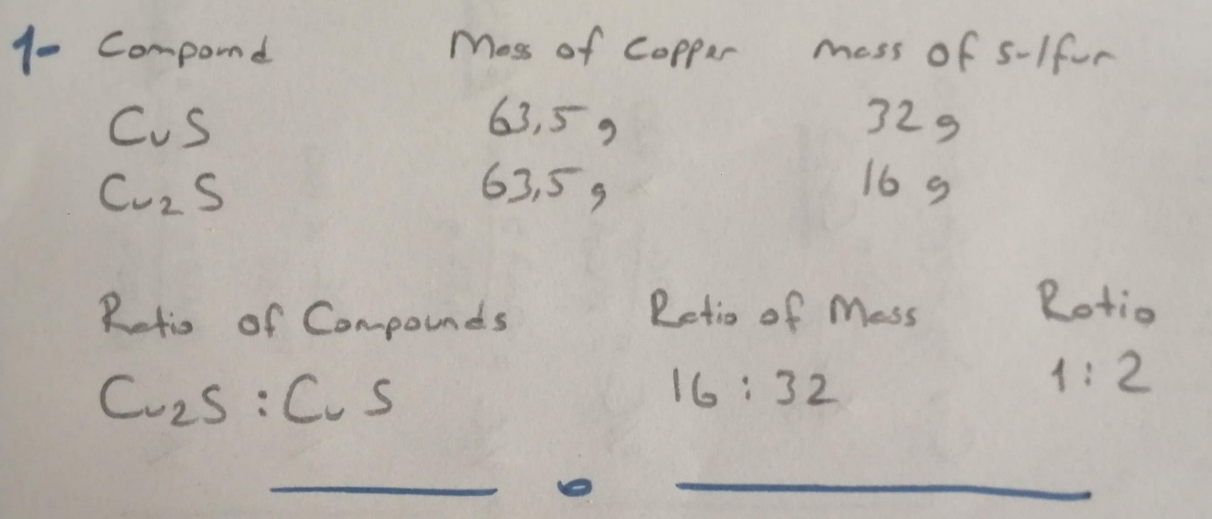

**2-**Explain how each of the following would affect your calculated value for the percentage of sulfur in the product:

**2a-**Some of the weighted copper reacted with oxygen to give CuO.

🡪Sulfur reacts with oxygen since copper which will react with sulfur decreases.At the end of the reaction, the sulfur percentage in the crucible decreases.

**2b-**Some of the copper did not react but remained as the metal.

🡪It may be due to low reactant sulfur. However, the percentage of sulfur in products does not change.

**2c-**Some of the wire assumed to be pure copper had oxidized to CuO before it was weighted as pure copper.

🡪Sulfur reacts with oxygen since there is less copper than calculated. At the end of the reaction, the sulfur percentage in the crucible decreases.

**3-**Write a balanced chemical equation for the reaction which takes place when copper is heated with an excess of sulfur in a covered crucible.

2Cu+(s) + S2-(s) 🡪(heat) Cu2S (s)

**Referenced sources:**

Websites:

<https://tr.wikipedia.org/>

<http://www.kimyaevi.org/>

<https://www.greelane.com/>

Books:

General Chemistry Principles and Modern Applications (10th Edition, Chapter 3 and Chapter 4).